**Electric Vehicle Route Planner**

**A Project Work Synopsis**

*Submitted in the partial fulfilment for the award of the degree of*

**BACHELOR OF ENGINEERING**

**IN**

## ARTIFICIAL INTELLIGENCE AND MACHINE

**LEARNING**

**Submitted by:**

**Pronoy Dey**

**Tanya Sharma**

**20BCS6400**

**20BCS6405**

**Under the Supervision of:**

**Dr.** Shweta Chauhan



**CHANDIGARH UNIVERSITY, GHARUAN, MOHALI - 140413,**

**PUNJAB**

**March 2023**

**Table of Contents**

Title Page i

Abstract ii

List of Figures iii

List of Tables iv

Timeline/Gantt Chart v

1. **INTRODUCTION** **1**
   1. Problem Definition 1
   2. Project Overview 1
   3. Hardware Specification 1
   4. Software Specification 1

1. **LITERATURE SURVEY 3**
   1. Literature Review Summary 8

1. **PROBLEM FORMULATION 10**

1. **RESEARCH OBJECTIVES** **12**

1. **METHODOLOGY 13**

1. **TENTATIVE CHAPTER PLAN FOR THE PROPOSED WORK 15**

1. **REFERENCES**  **16**

# *Abstract*

Electric Vehicles (EV’s) are becoming popular since past few years especially nowadays when prices of the fuel are so high and there’s so much of global warming. A lot of people are switching to electric vehicles as they are cost effective and most important they do not cause any pollution. The only problem that arises here is of the charging stations. In the beginning when electric vehicles came into light there were very few charging stations but over the years the number of them has increased. There are charging stations available but not as many as the normal petrol/diesel pumps we see around us so finding one for an owner of electric vehicle might be a problem as while on the road he doesn’t know how far the next station will be and would he be able to reach the next station without running out of battery in his vehicle. So in this report we will be discussing how electric vehicles work and how they have become so popular in the past few years and the most important part is how we are going to plan a proper route for an individual who owns an electric vehicle and want to know about the best route to reach his destination without his vehicle running out of battery.

# *List Of Figures*

***Figure Title page***

*Timeline of the Project v*

*Fig 1. Flowchart of Proposed Methodology 14 Fig 2. Electric Power Computation Diagram 5*

____________________________________________________________________

**iii**

# *List Of Tables*

***Table Title page***

*Table 2.1 Summary of Literature Reviews of previously proposed work 8*

__________________________________________________________________

**iv**

# *Timeline/Gantt Chart*

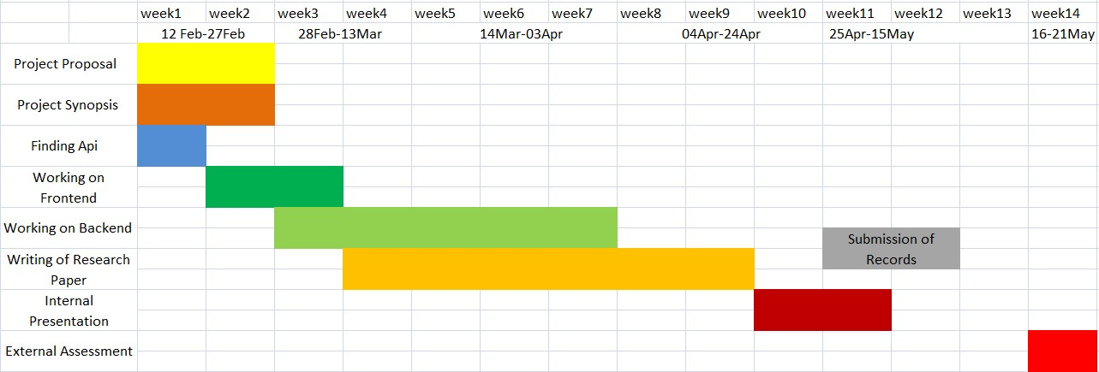

Timeline of the Project

__________________________________________________________________

**v**

**1 INTRODUCTION**

## 1.1 Problem Definition

Electric Vehicles (EV’s) are becoming popular since past few years especially nowadays when prices of the fuel are so high and there’s so much of global warming. A lot of people are switching to electric vehicles as they are cost effective and most important they do not cause any pollution. We are going to plan a proper route for an individual who owns an electric vehicle and want to know about the best route to reach his destination without his vehicle running out of battery.

## 1.2 Project Overview

Electrical vehicle (EV) based on electric system that pushes or drives a vehicle. No internal engine is used. The vehicle runs on electric power as electric source. The main advantage of electric vehicle is its efficiency of conversion of power through its electric motor. Nowadays commercial vehicles are also available. There are many countries which provided incentive to many users through lower tax, free parking and free charging facilities. On the other hand, the hybrid electric vehicle (HEV) is an alternative. Hybrid electric vehicles also have a gasoline engine in addition to an electric power train. Hybrid electric vehicles (HEVs) are powered by an internal combustion engine in combination with one or more electric motors that use energy stored in batteries. It has been used extensive in the last few years. At least one model in all the cars can have hybrid electric vehicle. The question arises: Which vehicle will lead market and which one is suitable for future? This paper is for examining the recent development of Electric Vehicle(EV’s) and suggest the future development in the area.

## 1.3 Software Specification

The following software specifications are required for the successful completion of the proposed project:

* Visual studio code
* Browser, HTML, CSS
* Chrome Developer Tools
* Bootstrap
* JavaScript
* Tom-Tom API

## 1.4 Hardware Specification

The hardware specifications required for the proposed project includes:

and GPU.

* A minimum of 8GB RAM. And GPU with at least 2GB RAM.
* A minimum of 20GB hard drive space.
* Internet connection for accessing online API

2

**2. LITERATURE REVIEW**

## The Motors

There are a number of motors available for electric vehicle: DC motors, Induction motor, DC brushless motor, permanent magnetic synchronous motor and Switched reluctance motor.

## A. DC motors

A DC motor is defined as a class of electrical motors that convert direct current electrical energy into mechanical energy.

Dc motor diagram

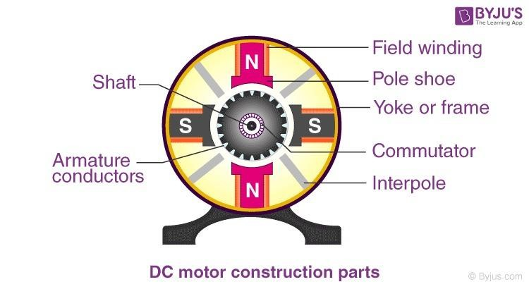

Today, most of the golf-carts are using DC motors. The power level is less than 4kW.

## Induction motor

It is a very popular AC motor. It also has a large market share in variable speed drive application such as air-conditioning, elevator or escalator. Many of the higher power electric vehicles, for more than 5kW, uses induction motor.

Induction Motor Diagram

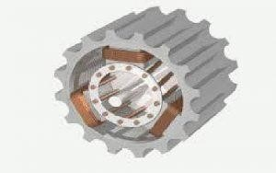

3

## Advantages

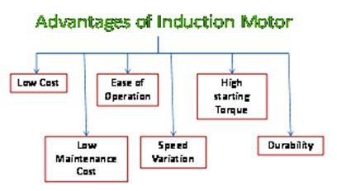

DC brushless

motor

The BLDC motor is widely used in applications including appliances, automotive, aerospace, consumer, medical, automated industrial equipment and instrumentation. The BLDC motor is electrically commutated by power switches instead of brushes.

Advantages of BLDC Motors

1. No wear and tear
2. Long life
3. Less noise or noiseless operation.

## E. Permanent magnetic synchronous motor

The stator is similar to that of an induction motor. The rotor us mounted with permanent magnets. The permanent magnet synchronous motors are very efficient, brushless, very fast, safe, and give high dynamic performance when compared to the conventional motors.

## Diagram of Permanent magnetic synchronous motor

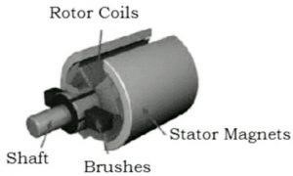

4

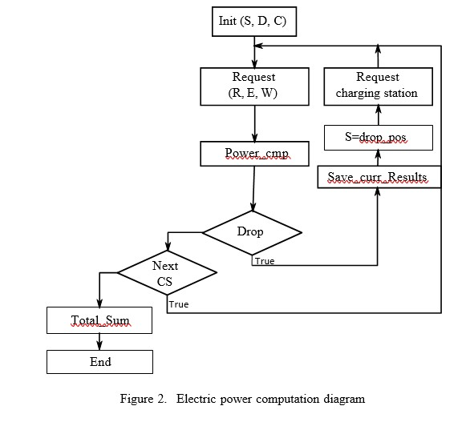

5

## 2.1 Literature Review Summary

Table 2.1 Literature review summary

|  |  |  |  |  |
| --- | --- | --- | --- | --- |
| **Author** | **Year** | **Region** | **Title** | **Description** |
| **Bailey et al.** | 2015 | Canada | Is awareness of public charging associated with consumer interest in plug-in electric vehicles? | * Investigation of whether visibility of public chargers has an impact on PEV demand. * There is no significant relationship between perceived existence of one charging station and PEV interest, however there is a weak yet significant relationship between perceived existence of multiple charging stations and PEV interest. |
| **Bunce et al.** | 2014 | U.K. | Charge up then charge out? Drivers’ perceptions and experiences of electric vehicles in the U.K. | * Questionnaires and interviews to assess drivers’ attitudes and experiences driving an EV before and after a three-month trial. * Before a three-month trial, 51% of drivers were willing to pay more for a less environmentally damaging vehicle. After the trial, 74% of drivers expressed willingness. |
| **Cahill et al.** | 2014 | Californi a | New car dealers and retail innovation in California’s plug-in electric vehicle market | * Interviews with automakers and dealers, and analysis on customer satisfaction data. * Overall, consumer experience at dealerships is much better for conventional vehicle buyers than PEV buyers. Introducing new methods for educating and scaling dealer competence regarding electric vehicles could greatly improve the consumer experience. |
| **CFA** | 2016 | U.S. | New data shows consumer interest in  electric vehicles is growing | * Second annual electric vehicle survey by Consumer Federation of America shows consumer interest in the technology is growing. * Electric vehicle model availability is increasing while prices continue to drop. * Electric vehicle sales are outpacing hybrid vehicle sales in their respective years of market introduction. |

6

|  |  |  |  |  |
| --- | --- | --- | --- | --- |
| **CFA** | 2015 | U.S. | Knowledge affects consumer interest in EVs, new EVs guide to address info gap | * Survey by Consumer Federation of America that shows how knowledge affects consumer interest in EVs. * Clear and significant correlation between EV knowledge and positive attitudes towards the technology. Positive attitudes and a willingness to purchase them are also correlated. For consumers that were more knowledgeable, there was a significant correlation between understanding and purchase desire. |
| **Edwards, Turrentin e & White** | 2016 | U.S. | PEV marketing to consumers: What’s missing? | * Three Plug-in Electric Vehicle Collaborative meeting presentations. * Discusses challenges and opportunities in EV market development, especially on consumer awareness and acceptance. |
| **Egbue**  **&**  **Long** | 2012 | U.S. | Barriers to widespread adoption of electric vehicles: An analysis of consumer attitudes and perceptions | * Survey that samples technology enthusiasts to determine attitudes toward EVs. * Consumer attitudes and uncertainty regarding EV battery technology and sustainability of fuel sources may be a barrier to widespread adoption; this uncertainty may stem from lack of understanding and familiarity. |
| **Gyimesi & Viswanatha n** | 2011 | U.S. | The shift to electric vehicles | * Interviews with executives from auto companies and survey of consumers to understand their attitudes towards EVs. * 45% of the drivers they surveyed have little to no understanding of EVs. * Consumers with better understanding are generally more willing to pay a premium for the technology. Nevertheless, even well informed consumers are sometimes unaware of the lifetime fuel savings that EVs offer. |
| **Krause et al.** | 2013 | U.S. | Perception and reality: Public  knowledge of  plug-in vehicles in  21  U.S. cities | * Survey analysis examines consumer knowledge of PEVs and current public policies. * Most survey respondents were misinformed regarding basic PEV characteristics. Nearly 95% of respondents were unaware of state and local policies. Misperceptions regarding potential fuel and maintenance cost savings can notably hinder PEV interest. |
| **Krupa et al.** | 2014 | U.S. | Analysis of a consumer survey on plug-in hybrid electric vehicles | * Survey analysis on PHEV market penetration to reveal quantitative patterns and correlations. * Advertising up-front incentives may be more effective than advertising long- term fuel savings * Targeting advertising and marketing towards progressive and environmentally concerned citizens may be more effective than those for a general audience * Displaying EV fuel savings in gallons, rather than dollars, may be more persuasive |

8

1. **PROBLEM FORMULATION**

Electric vehicles have recently received increasing attention because of their positive environmental and economic impacts; however, such vehicles are still not gaining widespread popularity for practical use given the inconvenience of limited battery capacity and long recharge times. To compensate for these drawbacks we build this project in which we are going to plan a proper route for an individual who owns an electric vehicle and want to know about the best route to reach his destination without his vehicle running out of battery. The question arises: Which vehicle will lead market and which one is suitable for future? There are charging stations available but not as many as the normal petrol/diesel pumps we see around us so finding one for an owner of electric vehicle might be a problem as while on the road he doesn’t know how far the next station will be and would he be able to reach the next station without running out of battery in his vehicle. So in this research paper we will be discussing how electric vehicles work and how they have become so popular in the past few years and the most important part of the research paper is how we are going to plan a proper route for an individual who owns an electric vehicle and want to know about the best route to reach his destination without his vehicle running out of battery

1. **RESEARCH OBJECTIVES**

The objective of this project is to identify the best route for E-Vehicles..

* + Our objective of the project is to detect the charging stations on map easily with accuracy and recommend the best route.
  + The main motive was to decrease the fuel consumption and Now a days lot of people are switching to electric vehicles as they are cost effective and most important they won’t cause any pollution.
  + The future of electric vehicles is bright everywhere. A lot of people are switching to electric vehicles as they are cost effective and most important they do not cause any pollution. All the recent studies, shows a positive picture of future of electric vehicles as a mode of road transportation.

## 5 METHODOLOGY

The following methodology will be followed to achieve the objectives defined for proposed research work:

* We have used html, css and bootstrap for frontend.
* We have used Tom Tom APi for maps and EV routing.
* In EV routing we have considered parameters like maximum charge of vehicle in kWh, vehicle weight. It's constant speed consumption in kWh/100km.We have considered that a car uses more power per 100km on a highway than it does on a city road.
* We have also considered live traffic data in our EV routing.
* We have also used different charger types , their power output and their plug type.

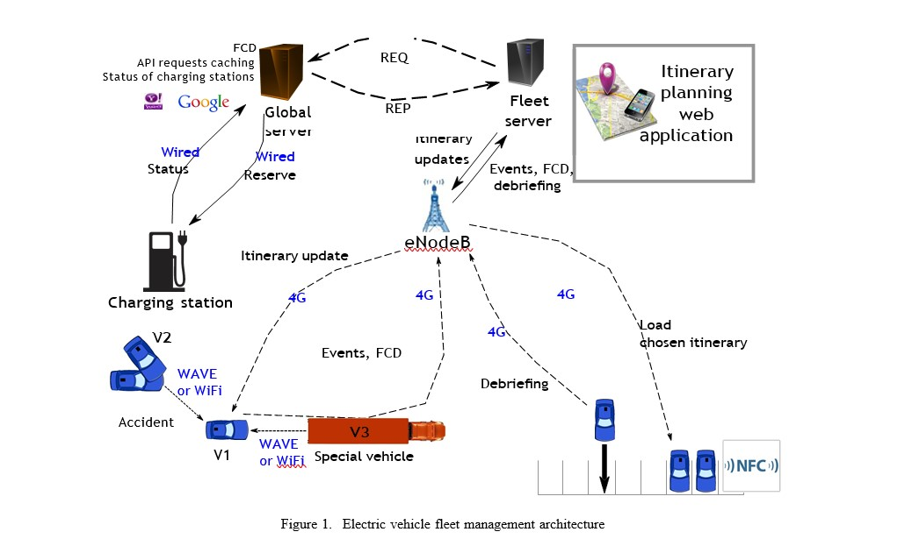

1. TENTATIVE CHAPTER PLAN FOR THE PROPOSED WORK

**CHAPTER 1: INTRODUCTION**

This chapter will cover the overview and blueprint of the project.

### CHAPTER 2: LITERATURE REVIEW

This chapter include the literature available for the proposed implementation of the project ideas. The findings of the researchers will be highlighted which will become basis of current implementation.

### CHAPTER 2: BACKGROUND OF PROPOSED METHOD

This chapter will provide introduction to the concepts which are necessary to understand the proposed system.

**CHAPTER 4: METHODOLOGY**

This chapter will cover the technical details of the proposed approach.

### CHAPTER 5: EXPERIMENTAL SETUP

This chapter will provide information about the subject system and tools used for evaluation of proposed method. Along with this the implementation detail of the networks will be discussed.

**CHAPTER 6: RESULTS AND DISCUSSION**

The result of proposed technique will be discussed in this chapter.

### CHAPTER 7: CONCLUSION AND FUTURE SCOPE

The major finding of the work will be presented in this chapter. Also directions for extending the current study will be discussed.

**7 REFERENCES**

1. “Energy consumption, co2 emissions and other considerations related to battery electric vehicles,” www.going-electric.org.
2. C. Cheng and J. Yan, “Research on energy supply modes of electric vehicle,” in Advances in

Electronic Engineering, Communication and Management Vol.2, ser. Lecture Notes in Electrical Engineering, D. Jin and S. Lin, Eds. Springer Berlin Heidelberg, 2012, vol. 140, pp. 291– 296.

1. G. Remy, S. Mehar, T. Sophy, S.-M. Senouci, F. Jan, and Y. Gourhant, “Green fleet management architecture: Application to economic itinerary planning,” in Globecom Workshops (GC Wkshps), 2012 IEEE, 2012, pp. 369–373.
2. J. Fakcharoenphol and S. Rao, “Planar graphs, negative weight edges,

shortest paths, and near linear time,” in Foundations of Computer Science, 2001. Proceedings. 42nd IEEE Symposium on, 2001, pp. 232– 241.

1. A. Artmeier, J. Haselmayr, M. Leucker, and M. Sachenbacher, “The shortest path problem revisited: Optimal routing for electric vehicles,” in KI 2010: Advances in Artificial Intelligence, ser.

Lecture Notes in Computer Science, R. Dillmann, J. Beyerer, U. Hanebeck, and T. Schultz, Eds. Springer Berlin Heidelberg, 2010, vol. 6359, pp. 309–316.

1. “Green navigation - energie optimales routing für elektrofahrzeuge,” http://www.greennav.org.
2. D. B. Johnson, “Efficient algorithms for shortest paths in sparse networks,” J. ACM, vol. 24, no. 1, pp. 1–13, Jan. 1977.
3. S. Chen and K. Nahrstedt, “On finding multi-constrained paths,” in Communications, 1998. ICC 98. Conference Record. 1998 IEEE Inter- national Conference on, vol. 2, 1998, pp. 874–879 vol.2.
4. M. Sachenbacher, M. Leucker, and A. Artmeier, “Efficient energy- optimal routing for electric vehicles,” in Proc. Twenty-Fifth AAAI Conference on Artificial Intelligence, 2011, pp. 1402– 1407.
5. J. Eisner, S. Funke, and S. Storandt, “Optimal route planning for electric vehicles in large networks,” in Proc. Twenty-Fifth AAAI Conference on Artificial Intelligence, 2011, pp. 1108–1113.
6. “Open street map,” www.openstreetmap.org/.
7. “Carstations,” http://www.carstations.com.
8. “Chargemap.com,” http://chargemap.com/.
9. Guzzella and Amstutz, The QSS Toolbox Manual, 2005.
10. Guzzella and Sciarretta, Vehicle Propulsion Systems, 2005.